# VISVESVARAYA TECHNOLOGICAL UNIVERSITY

**JNANA SANGAMA, BELAGAVI - 590018**



**TECHNICAL SEMINAR REPORT (18ECS84)**

**ON**

## “DESIGN THINKING FOR HUMAN INTERACTIONWITH FLEXIBLE ELECTRONICS”

*Submitted in partial fulfilment of the requirements for the award of the degree of*

**BACHELOR OF ENGINEERING**

**IN**

**ELECTRONICS AND COMMUNICATION**

**For the Academic year 2022-2023**

*Report Submitted by*

**PUNIT.K.N (1MV19EC083)**

***Under the guidance of***

**Mrs. Ekta Jolly**

Associate Professor / Department of ECE



**DEPARTMENT OF ELECTRONICS AND COMMUNICATION ENGINEERING SIR M. VISVESVARAYA INSTITUTE OF TECHNOLOGY**

Bengaluru -562157

## MARCH 2023

**SIR M. VISVESVARAYA INSTITUTE OF TECHNOLOGY**

Bengaluru -562157

**DEPARTMENT OF ELECTRONICS AND COMMUNICATION ENGINEERING**



### **CERTIFICATE**

This is to certify that the Technical Seminar (18ECS84) on **“DESIGN THINKING FOR HUMAN INTERACTION WITH FLEXIBLE ELECTRONICS”** prepared by **PUNIT.K.N (1MV19EC083)**, a bonafide student of **SIR M. VISVESVARAYA INSTITUTE OF TECHNOLOGY**. The report is in partial fulfilment of the requirements for the award of the degree of “**Bachelor of Engineering**” in **Electronics and Communication Engineering.** From the **Visvesvaraya Technological University**, Belagavi, Karnataka, India, during the academic year 2022-2023. It is certified that all corrections/suggestions indicated for Internal Assessment have been incorporated in the report submitted to the Department. The Seminar report has been approved as it satisfies the academic requirement in respect to the work prescribed for the said Degree.

------------------------------- ------------------------------ ----------------------------Signature of the Guide Signature of HOD Signature of Principal

**Mrs. Ekta Jolly Dr. V. G. Supriya Prof. Rakesh**

Associate Professor Professor & Head Principal

Dept of ECE Dept of ECE Sir MVIT, Bengaluru

**DECLARATION**

I hereby declare that the Seminar Report on **“DESIGN THINKING FOR HUMAN INTERACTION WITH FLEXIBLE ELECTRONICS”** undertaken has been presented under the guidance of **Mrs. Ekta Jolly**, Associate Professor, Department of Electronics and Communication Engineering, Sir M. Visvesvaraya Institute of Technology, Bengaluru. This topic has not been submitted previously in the Dept. of ECE and any other Departments of Sir MVIT.

Place: Bengaluru PUNIT.K.N

Date: 28-03-2023 1MV19EC083

# ACKNOWLEDGEMENT

A technical seminar is incomplete if it fails to thank all those instrumental in the successful completion of the report.

I welcome this opportunity to convey my regards, gratitude, respect, decorations, and a lot of thanks to them who inspired me to complete this report in the stipulated period of time provided.

It’s a great privilege to place on record my deep sense of gratitude to the Management and **Prof. Rakesh S.G.**, Principal, Sir M. Visvesvaraya Institute of Technology, who patronized throughout our career & for the facilities provided to carry out this work successfully.

I would like to extend my heartfelt gratitude to **Dr. V. G. Supriya**, Professor and Head, Dept. of ECE, Sir M. Visvesvaraya Institute of Technology, for her constant support and encouragement.

I would like to thank our project guide **Mrs. Ekta Jolly**, Associate Professor**,** Dept. of ECE, Sir M. Visvesvaraya Institute of Technology, for her valuable guidance and support in the completion of this seminar.

I thank the teaching and non-teaching staff members who have helped me directly or indirectly in completion of this seminar.

Finally, I would also like to thank my parents and friends who rendered me active support for the completion of this seminar report. I acknowledge them with a lot of gratitude and regard and without all of the above this report may not be easily possible.

**PUNIT.K.N**

**(1MV19EC083)**

**ABSTRACT**

Human interaction with flexible electronics involves the use of electronic devices that are made using flexible materials and can bend, stretch, and conform to the contours of the human body or other flexible surfaces. These devices can enhance human interaction with technology by providing more natural and intuitive ways of interacting with devices.

One of the main areas where flexible electronics are being used to improve human interaction is in the development of wearable devices. These devices can be worn on the body, allowing users to interact with them hands-free. For example, a flexible smartwatch could be worn on the wrist and provide notifications, control music, or monitor health metrics.

Flexible electronics can also be used to create augmented reality (AR) interfaces that overlay digital information onto the physical world. This can enable users to interact with virtual objects and information in a more natural and intuitive way, using gestures and movements.

Soft robotics is another field where flexible electronics can enhance human interaction. Soft robots made from flexible materials can move and interact with the world in a more organic way, and flexible electronics can be used to create sensors and actuators that respond to touch and other stimuli.

Smart clothing is another area where flexible electronics can enhance human interaction. Clothing with embedded sensors can monitor and adjust to the wearer's needs, such as adjusting insulation based on body temperature or tracking posture and providing feedback to improve alignment.

Overall, flexible electronics offer a wide range of possibilities for enhancing human interaction with technology. As the technology continues to develop, we can expect to see even more exciting applications that will transform the way we interact with devices.

**CONTENTS**

*Certificate* i

*Declaration* ii

*Acknowledgement* iii

*Abstract* iv

*Contents* v

*List of figures*  vi

**Chapters**  **Titles**  **Page No.**

CHAPTER 1: INTRODUCTION 1

CHAPTER 2: LITERATURE SURVEY 3

CHAPTER 3: PROCESS OF SPEAKING 5

CHAPTER 4 METHODS 6

CHAPTER 5: MERITS AND DEMERITS 11

CHAPTER 6: FUTURE SCOPE 12

CHAPTER 7: CONCLUSION 13

*References* 14

**LIST OF FIGURES**

**Fig No Figure Name Page No.**

Fig 1.1 Many people talking at one 2

Fig 3.1 Process of speaking 5

Fig 4.1 Electromyography signal generation 6

Fig 4.2 Electromyography Instruments 7

Fig 4.3 Block diagram of EMG 7

Fig 4.4 Interfacing with electromyographer and body 8

**CHAPTER 1**

**INTRODUCTION**

Flexible electronics is a rapidly growing field of technology that involves the development of electronic devices and circuits that can bend, twist, and stretch without breaking or losing their functionality. Unlike traditional electronics, which rely on rigid materials such as silicon and glass, flexible electronics use a variety of materials, including organic polymers, metals, and semiconductors, to create components that are both flexible and electrically conductive.

The development of flexible electronics has been driven by the need for more adaptable and versatile electronic devices. Traditional electronics are limited in their application because they are rigid and cannot be easily integrated into various forms or surfaces. With the advent of flexible electronics, new applications have emerged, such as wearable devices, flexible displays, and smart textiles. These new applications have the potential to revolutionize fields such as healthcare, consumer electronics, and automotive industries.

The most commonly used materials for flexible electronics are organic polymers, which have the property of being both flexible and electrically conductive. These materials can be printed, coated, or deposited on flexible substrates such as plastics, textiles, or paper. Other materials used in flexible electronics include metals such as gold and silver, and semiconductors such as silicon and graphene.

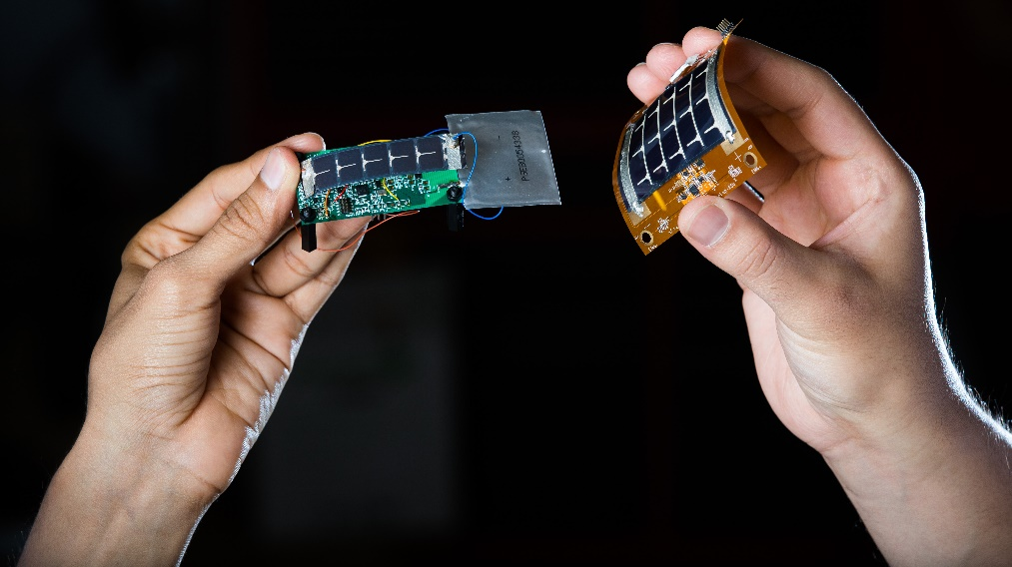

Fig:

The fabrication process of flexible electronics involves a variety of techniques, including inkjet printing, roll-to-roll processing, and photolithography. These techniques enable the deposition of electronic components such as transistors, capacitors, and sensors on flexible substrates. Once the electronic components are deposited on the flexible substrate, they can be interconnected using conductive traces or wires. The electrical properties of the components are preserved even when the substrate is bent or twisted, allowing for the creation of flexible circuits.

One of the key advantages of flexible electronics is their ability to conform to different shapes and surfaces, making them ideal for use in wearable devices. For example, flexible sensors can be integrated into clothing to monitor vital signs, while flexible displays can be embedded in clothing or accessories to provide information and notifications to the wearer.

Another important application of flexible electronics is in the field of healthcare. Flexible sensors and devices can be used to monitor patient health and provide real-time feedback to healthcare professionals. This can lead to more personalized and effective healthcare, as well as reduced healthcare costs.

In conclusion, flexible electronics is a rapidly growing field of technology that has the potential to revolutionize the way we interact with electronic devices. By using flexible and adaptable materials, electronic devices can be integrated into a variety of surfaces and shapes, enabling new applications in areas such as wearables, healthcare, and consumer electronics. As the field continues to develop, we can expect to see more innovative and exciting applications emerge in the near future.

**CHAPTER 2**

**LITERATURE SURVEY**

It is becoming evident the next generation of displays will be flexible, having made their way from research prototypes to consumer products [1]. They are lightweight, flexible and thin, and interactive. Emerging flexible technologies enable a multitude of flexible interactive devices, covering a range of modalities; from those resembling paper documents to others like the newest smartphones. Beyond being interesting new pieces of technology, it is necessary to investigate how people will interact with flexible devices. How are these interactions different from those with rigid devices? What form factors would create better interactions? Are there specific contexts, applications, or user populations that could benefit most from flexible devices, with or without displays? How should we design for them? Are there scenarios or spaces where flexible devices are not appropriate? These research questions are critical to creating a successful user experience when interacting with a device. It is crucial to start addressing them in parallel to the design and the development of the technology.

In this paper, we focus on the research question: can flexible input improve how we interact with our handheld devices? Our research investigates the design and evaluation of new input and interaction techniques for this new generation of interactive devices. We present research on deformable user interfaces conducted at the Creative Interactions Lab at Carleton University, discussing interaction techniques and showing various applications of such deformable flat UIs such as bend passwords, game input, and targeting vision impaired users.

[2] Ever evolving advances in thin-film materials and devices have fuelled many of the developments in the field of flexible electronics. These advances have been complemented with the development of new integration processes, enabling wafer-scale processes to be combined with flexible substrates. This has resulted in a wealth of demonstrators in recent years. Following substantial development and optimization over many decades, thin film materials can now offer a host of advantages such as low cost and large area compatibility, and high scalability in addition to seamless heterogeneous integration.

[3] Active-matrix circuits for switching pixels in liquid crystal displays. From flexible displays, the scope has expanded to include more compelling and more technically challenging opportunities in biomedical devices which are minimally invasive and which can be worn or implanted. To meet these requirements new design strategies, materials and fabrication schemes have to be considered and investigated. Here, mechanical engineering is as important as circuit design and curvilinear, ergonomic, or biologically inspired layouts are often exploited as alternative to more standard approaches [2-4]. However, flexible electronic circuits still remain at the heart of any flexible system and their performance and fabrication schemes usually define applications and costs. This paper provides a general overview of materials and technologies for flexible electronics. The focus is on devices and circuits which are fabricated directly on polyimide foils and based on amorphous Indium Gallium Zinc Oxide (aIGZO) and high-k dielectric. Section III shows an original approach to integrate electronics into textiles which can be used in medical applications. Finally, flexible electronics on very thin and biocompatible substrate offers unprecedented bending radii, conformability and lightness, all attributes which are important for smart-skin, tissue sensing and implantable devices.

[4] Suitable stretchable electronics is the key to promote future human-machine collaboration to facilitate processes in daily life. Sensors and actuators on humans will enable a close and yet unhesitating interaction with robots by translating data between biological and technical systems. This paper describes our first approach for chip integration and stretchable interconnect manufacturing in order to achieve reliable stretchable interconnects. Therefore, inkjet printer silver horseshoe-interconnects with a radius of 500µm on spin coated polyurethane substrate are tested on a self-developed stretch test setup. More than 400 stretch and release cycles on 10% and 20% stretching were achieved. Furthermore, a polymer chip-embedding process by polymer casting is shown to apply fan-out redistribution layer directly on thin chip carrier. Those carriers can be integrated in stretchable foils in order to achieve miniaturized and low-profile assemblies for human-machine interfaces.

**CHAPTER 3**

**FLEXIBLE ELECTRONICS**

**3.1 MATERIALS AND TECHNOLOGIES**

The fundamental properties of thin-film materials, as well as the quality of various device interfaces, give rise to inherent limitations in device performance. For instance, consider the ring oscillator. As one of the most essential building blocks in many systems, it is fundamental to many emerging technologies, such as radio-frequency identifi- cation (RFIDs) tagging. A large number of design param- eters influence the oscillation frequency of ring oscillators. These include geometric attributes, parasitic capacitance, and the supply voltage. However, these adjustments are often dwarfed by the inherent performance limitations of the transistors. Considering the field-effect mobility as a key performance indicator, one can populate a stage delay Vs mobility map to illustrate the mobility dependency of operating speed of ring oscillators using common semi- conductors, as shown in Fig:3.1. The indicated values are from a variety of sources and the observed scatter is indicative of typical variation in device layout, parasitic capacitance, and supply voltage. Despite this, an overall distinction can be made between different classes of materials.

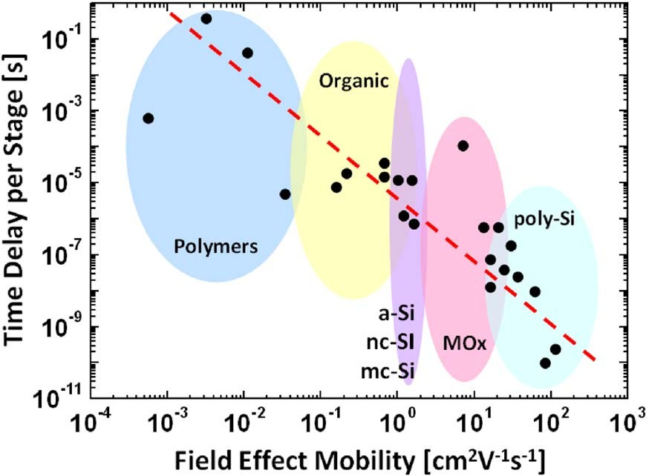

Fig:3.1

**3.2 CHIP EMBEDDING**

The chip embedding into polymer aims at generating certain gradient between the rigid silicon and the stretchable polymer. Recently the 3D-printing process for embedding of additive IC-devices was demonstrated. In this paper we used an even easier way for chip embedding: polymer casting process. The advantage against 3D printing is not as size limited and even roll-to-roll process enabling. Fig:3.2.1 shows the casting process, which will be described in detail as follows.

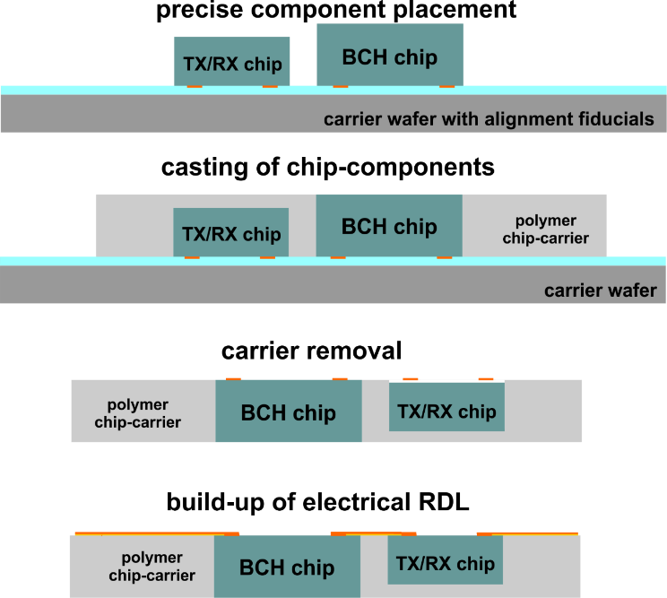

Fig:3.2.1

The fabrication process starts with exact placement of chip-components on the temporary wafer carrier. For this a glass-mask with alignment fiducials was used. With this method the relative alignment between the mask and the chips on temporary carrier is maintained. After this step, UVdefinable polymer with high thermal stability and low viscosity is used for chip embedding. After the material deposition, the carrier wafer including the chips is pressed with defined force parallel against a flat substrate with release film. The setup is exposed with UV-light. The thickness of the polymer chip-carrier is defined by the thickest chip component placed on the carrier wafer. After UV-curing, the temporary carrier is removed. As a result, a polymeric chipcarrier with exposed electrical contact pads results. By subsequent build-up of metal multilayer stack an electrical redistribution network for routing electrical signals can be realized. In order to contact the electrical pads of embedded chips and also realize interconnects between chips and provide the connection to stretchable interconnects, the build-up of metallic redistribution directly on the chip-carrier need to be carried out. Therefore, a PVD deposition of WTi as an adhesion and diffusion barrier and Cu as seed layer are necessary. Following the negative dry-film photoresist DuPontTM MX5015 is laminated, which is stable in contact with chemicals used in the subsequent chemical and electroplating steps. The next steps of mask-based UV exposure, PEB and development structure the resist.

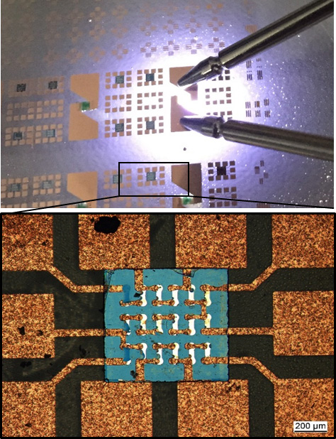

Fig:3.2.2

Subsequently DC electroplating using a deposition of thick Cu-metallization acid copper plating formulation (NB Semiplate Cu 100) is used in order to raise the Cu thickness to 2 µm -°3 µm. After resist stripping the wet differential etching of Cu-seed and WTi-layer follows. Fig:3.2.2 shows an exemplary result of structuring of Cu-contacts on the top of embedded chip-carrier.

**3.3 HUMAN–MACHINE INTERACTIVITY**

Smartphones have significantly increased user interaction levels, but they are not without their issues. The rigidity of handheld devices presents several challenges to ideal use, including finger occlusion during interaction, limited interaction areas, and touch unavailability in certain contexts such as wearing gloves or for individuals with mobility disabilities.

One potential solution to these challenges is the development of flexible devices. Flexible electronics offer deformation as an additional input source to touch, buttons, and tilt, providing users with a new means of interaction. Specifically, bend gestures have become a focus of research in this area. These gestures are created by curving a portion of a flexible device, such as bending the top right corner of a flexible smartphone upwards. Bend gestures are classified based on various factors, including gesture location, direction, size of the bend area, angle, edge, and speed and duration of the bend. By leveraging these factors, bend gestures have the potential to address the limitations of traditional touch-based input and expand the range of possible interactions.

Overall, flexible devices offer a promising avenue for expanding the capabilities of handheld electronics. Through the use of bend gestures, these devices can provide users with an additional input source that is not limited by the constraints of touch. With continued research and development, flexible devices have the potential to address many of the challenges associated with rigid handheld devices, providing a more seamless and accessible user experience for all.

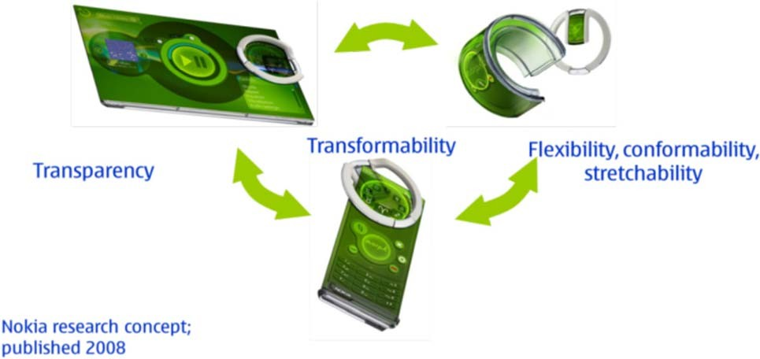

Fig:3.3.1, Transformability concept.

**CHAPTER 4**

**METHODOLOGY**

**4.1 DESIGN THINKING**

Tim Brown, Executive Chair of IDEO says “Design thinking is a human-centered approach to innovation that draws from the designer’s toolkit to integrate the needs of people, the possibilities of technology, and the requirements for business success”. Research and development personnel and designers are similar in a sense that they create the way organizations develop products, services, processes, and strategy. The five stages of design thinking are follows; Empathize research your users’ needs. Define state your users’ needs and problems. Ideate challenge assumptions and create ideas. Prototype start to create solutions. Test try your solutions out. By using DTA, decisions can be made based on what users (customers) really want instead of relying only on historical data or making risky bets based on instinct instead of evidence as illustrated in Fig:4.1.1.

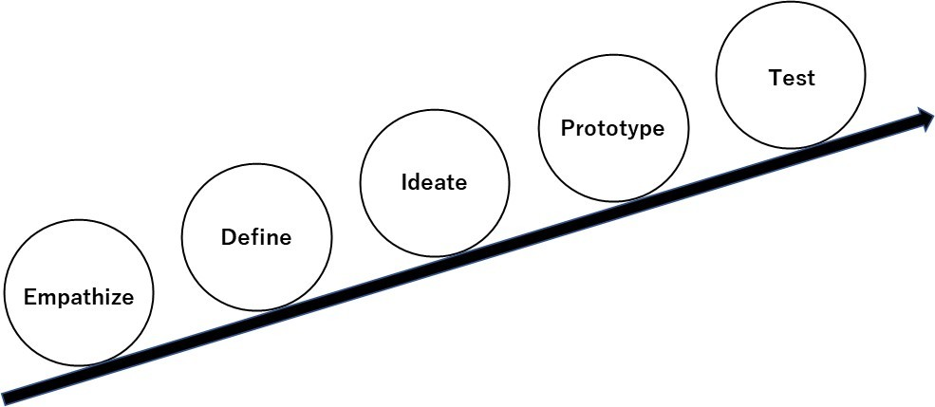

Fig:4.1.1 Five steps outlining the flow of the DTA (by IDEO).

**4.2 FLEXIBLE ELECTRONICS APPROACH**

A number of studies have been conducted with flexible electronics technologies that can provide a better interface between devices and human. Liu et al. presented a carbon-based formulation that is suitable for stencil printing on textiles to fabricate stretch and flex sensors for the detection of human joint movement . AlMohimeed et al. presented a wearable ultrasonic sensor made of a polyvinylidene fluoride film to measure skeletal muscle contractile properties as a quantitative assessment tool. Ozgio et al. presented non-intrusive (“wear and forget”) patch platform for patient monitoring. Diotallevi et al. presented the evaluation of the degradation of the radiation gain of on-skin UHF antennas in common gestures by a combined mechanical-electromagnetic model. Beeby et al. presented research on printed piezoelectric films, ferroelectret fabrics, spray coated solar cells, fabric-based inductive wireless power transfer and textile-based super capacitors. An example of a textile-based power module is shown in Fig:4.2.1.

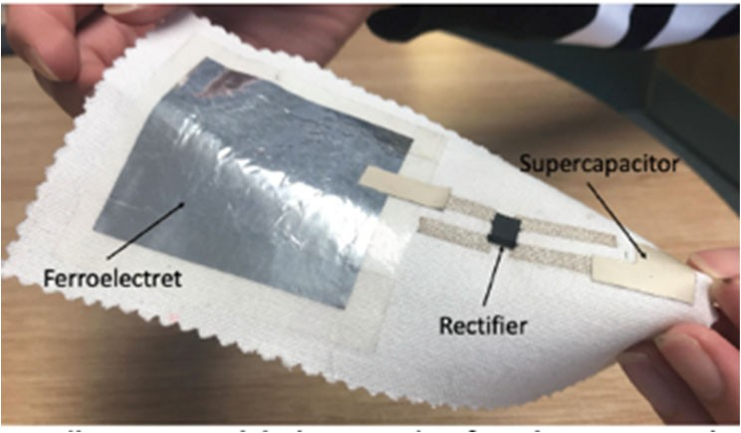

Fig:4.2.1 Textile power module by Beeby *et al*

Yi et al. presented a fully printed strain sensor consisting of carbon ink coating layer and interdigitated shape silver in electrodes solidified on a polyimide substrate. Karanassios reviewed trends on sensor research, development and commercialization. Also sensor-powering schemes, ranging from energy scavenging and harvesting to self-powering and power-management, were outlined.

**4.2.1 DISCUSSION**

According to Watanabe, “The design of the user interface becomes important, and what is the ideal of the user interface? It is actually the way tools should be, like in the Stone Age. When you use a pencil, you don't always think about how comfortable the pencil is to use. The pencil becomes transparent and does not come up in our consciousness, or we might say that it becomes a part of our human system. We believe that the ideal interface design is to be transparent as well”.

Smartphones are still something special to carry. Styles, functions and usability are key factors for users to select. With increasing functions, users may need to learn how to use them by tutorials (no more instruction manuals). But those phones seem to set a new culture of lifestyle and they will become “transparent” soon.

There are two aspects to consider when devices interface with the human.

* Comfortable communication interaction

Typing, flicking and pinching are common way of interacting with smart phones now. Voice recognition has been around but it is not well adopted because communication with voice is modal and requires step-by-step interaction which takes time, and also voice is open to public-type communication and normally users do not want others to listen. So, interface with fingers still remains a natural choice. Flexible and foldable keyboard interfaces which could be wearable on wrists would pose a good medium. Wearable glasses would be a good way for information display with combination with smart phones. Gestures or dancing movement detection could be used for communication purposes. But users are not used to such gestures. Watches already interface with smartphones, but typing from watch window is not practical.

Developing interfaces for disabled or handicapped people needs to be considered for equal opportunity. For such applications, operation by foot, gesture type, eye tracking, skin move and brain wave communication will be promising future interactive technologies with flexible electronics.

* Transparent vital data communication

Vital data, such as blood pressure, heart beat, oxygen saturation, and excretion monitoring are troublesome and uncomfortable for disabled people and patients. So wear and forget-type intrusive or non-intrusive patch-type vital monitors are very helpful, especially with self-powered capability. Microchip implant under skin could be a practical application possibly with flexible electronics technologies. Personal IDs can be embedded to communicate with external devices using inductive wireless power. In such cases, users do not need to communicate with devices.

Meeting Sustainable Development Goals (SDGs) is now required for any kind of activity. Considering environmental protection, such as energy savings, environmental friendly material usage and recycling or disposal methods are mandatory. Wearable devices with textiles may be designed in a way so that recycling of materials can easily be done. Power harvesting from the human body or movement, and flexible solar cells are encouraging technologies for deployment in energy-autonomous devices.

**CHAPTER-5**

**APPLICATIONS**

Flexible electronics have a wide range of potential applications, especially in the field of human interaction. Here are some examples of how flexible electronics can be used in this context:

**1. Wearable sensors:** Flexible electronics can be used to create wearable sensors that monitor vital signs such as heart rate, blood pressure, and body temperature. These sensors can be integrated into clothing, wristbands, or other wearable devices, providing real-time feedback on a person's health and fitness.

**2. Smart clothing:** Flexible electronics can be used to create smart clothing that responds to a person's movements and environment. For example, clothing with embedded sensors can adjust its temperature or provide support in response to changes in posture or activity level.

**3. Prosthetics:** Flexible electronics can be used to create prosthetic limbs that are more comfortable and functional than traditional rigid prosthetics. These devices can be designed to conform to a person's body shape and provide better range of motion, improving quality of life for amputees.

**4. Virtual and augmented reality:** Flexible electronics can be used to create wearable devices that enhance virtual and augmented reality experiences. For example, a flexible display could be worn as a head-mounted display, providing an immersive visual experience for gaming or training applications.

**5. Assistive technology:** Flexible electronics can be used to create assistive technology devices for people with disabilities. For example, a flexible keyboard or touchpad could be used by people with limited mobility, allowing them to interact with computers or mobile devices more easily.

Overall, flexible electronics have the potential to revolutionize the way humans interact with technology and with each other, creating new opportunities for innovation and improving quality of life.

**CHAPTER-6**

**ADVANTAGES AND DISADVANTAGES**

* **ADVANTAGES**

While flexible electronics have many advantages in the context of human interaction, there are also some potential disadvantages to consider. Here are some examples:

1. Limited durability: Flexible electronics may be less durable than traditional rigid electronics, which could limit their lifespan and require more frequent replacement or repair.

2. Limited range of applications: While flexible electronics have a wide range of potential applications, there are still some areas where they may not be suitable. For example, they may not be able to withstand extreme temperatures or harsh environments, which could limit their use in certain industries such as aerospace and defense.

3. Complexity of manufacturing: The manufacturing process for flexible electronics can be more complex and expensive than for traditional rigid electronics. This could limit their adoption in some applications or industries where cost and scalability are important factors.

4. Reduced performance: Flexible electronics may not be able to match the performance of traditional rigid electronics in terms of speed and power. This is because the materials used in flexible electronics have lower electrical conductivity and other properties that can impact performance.

5. Health and safety concerns: Some types of flexible electronics, such as those with embedded sensors or antennas, could raise health and safety concerns if they come into direct contact with the skin for extended periods of time.

Overall, while flexible electronics have many advantages in the context of human interaction, it is important to consider their potential drawbacks and limitations when evaluating their use in specific applications.

* **DISADVANTAGES**

There are several difficulties that can be faced when using flexible electronics. Here are some examples:

1. Materials selection: Choosing the right materials for flexible electronics can be challenging. Materials must be able to withstand repeated bending and stretching without breaking or degrading, and must also be compatible with other materials used in the device.

2. Manufacturing complexity: The manufacturing process for flexible electronics is more complex than for traditional rigid electronics. This is because the materials used are more difficult to work with and require specialized equipment and techniques.

3. Electrical performance: The electrical performance of flexible electronics can be lower than that of traditional rigid electronics. This is because the materials used in flexible electronics have lower electrical conductivity and other properties that can impact performance.

4. Integration with other components: Integrating flexible electronics with other components can be challenging. This is because flexible electronics are often custom-made for specific applications, and may not be compatible with off-the-shelf components.

5. Cost: The cost of producing flexible electronics can be higher than that of traditional rigid electronics. This is because the materials used are often more expensive, and the manufacturing process is more complex.

6. Limited durability: Flexible electronics may not be as durable as traditional rigid electronics, which could limit their lifespan and require more frequent replacement or repair.

Overall, while flexible electronics offer many advantages, there are also significant challenges that must be overcome to make them practical for widespread use in various applications.

**CHAPTER 7**

**FUTURE ENHANCEMENT**

Flexible electronics are a type of electronics that can be bent, twisted, and shaped to fit the contours of the human body or other flexible surfaces. As these technologies continue to advance, there are several potential enhancements that could improve human interaction with them:

**1. Wearable Devices:** The development of wearable devices has been one of the most significant areas of advancement in flexible electronics. These devices can be worn on the body, allowing users to interact with them hands-free. For example, a flexible smartwatch could be worn on the wrist and provide notifications, control music, or even monitor health metrics.

**2. Augmented Reality:** Flexible electronics could be used to create augmented reality (AR) interfaces that overlay digital information onto the physical world. This could enable users to interact with virtual objects and information in a more natural and intuitive way, using gestures and movements.

**3. Soft Robotics:** Soft robotics is a rapidly growing field that involves the use of flexible materials and electronics to create robots that can move and interact with the world in a more organic way. Flexible electronics could be used to create soft sensors and actuators that can be integrated into these soft robots, allowing them to respond to touch and other stimuli.

**4. Smart Clothing:** Flexible electronics could be used to create smart clothing that can monitor and adjust to the wearer's needs. For example, a jacket with embedded sensors could adjust its insulation based on the wearer's body temperature, or a shirt could track the wearer's posture and provide feedback to improve their alignment.

**5. Haptic Feedback:** Haptic feedback is a technology that allows users to feel sensations through their skin, such as vibrations or pressure. Flexible electronics could be used to create haptic feedback interfaces that provide tactile feedback in response to user input, enhancing the sense of touch in virtual and augmented reality environments.

In summary, flexible electronics have the potential to significantly enhance human interaction with technology, enabling new forms of wearables, augmented reality, soft robotics, smart clothing, and haptic feedback interfaces. As these technologies continue to develop, we can expect to see even more exciting innovations in the field.

**CHAPTER 8**

**CONCLUSION**

In conclusion, the development of flexible electronics has the potential to revolutionize human interaction with technology. These technologies can be bent, twisted, and shaped to fit the contours of the human body, allowing for more natural and intuitive interactions. Wearable devices, augmented reality interfaces, soft robotics, smart clothing, and haptic feedback interfaces are just some of the areas where flexible electronics could enhance human interaction. As these technologies continue to advance, we can expect to see even more exciting innovations in the field. Overall, the future of human interaction with flexible electronics looks promising and is an area of ongoing research and development.

**REFERENCES**

1. Design Thinking for Human Interaction with Flexible Electronics Mitsuhiko Nagata, Ph.D. Products Development Department, Technology Headquaters, Azbil Corporation, Japan .
2. Flexible Electronics: The Next Ubiquitous Platform By Arokia Nathan, Fellow IEEE, Arman Ahnood, Matthew T. Cole, Sungsik Lee, Member IEEE, Yuji Suzuki, Pritesh Hiralal, Francesco Bonaccorso, Tawfique Hasan, Luis Garcia-Gancedo, Andriy Dyadyusha, Samiul Haque, Piers Andrew, Stephan Hofmann, James Moultrie, Daping Chu, Andrew J. Flewitt, Andrea C. Ferrari, Michael J. Kelly, John Robertson, Fellow IEEE, Gehan A. J. Amaratunga, and William I. Milne
3. Deformable User Interfaces: Using Flexible Electronics for Human Computer Interaction Audrey Girouard and Alexander Keith Eady School of Information Technology Carleton University Ottawa, Canada.
4. High Performance Flexible Electronics for Biomedical Devices Giovanni A. Salvatore, Niko Münzenrieder, Student Member, IEEE, Christoph Zysset, Student Member, IEEE, Thomas Kinkeldei, Luisa Petti, Student Member, IEEE, and Gerhard Tröster, Senior Member, IEEE
5. Flexible and stretchable redistribution layer with embedded chips for human-machine interface Martin Schubert1,4,*, Laura Wambera1,4, Olha Mudrievska1, Krzysztof Nieweglowski1,4, Jens Wagner2,4, Johannes Partzsch3,4, Christian Mayr3,4, Frank Ellinger2,4, Karlheinz Bock1,4.